PRE-TRIAL WITNESS INTERVIEWS

AUDIO TAPE RECORDING

1 Equipment

1.1 A minimum of two NEAL 8221P Portable Cassette Tape Recorders (with plate microphones) will be supplied to each Area / HQ Casework Divisions along with one Neal 6226 High Speed Copier.

1.2 Each recorder will be supplied with a head cleaning cassette and 16 cassette tapes. Further tape supplies can be purchased direct from the CPS Stationery Contractor (Office Depot), catalogue no. 543449, Pack of 5 TDK C90 Cassette Tapes @ £1.13 per pack.

1.3 There is a 12 months return to factory warranty for each machine. Further guidance on reporting faults will be issued by HQ Procurement.

2 Integrity of the Master Audio Tape

2.1 It is important that the integrity of the master audio tape is maintained and the tape is regarded by the court as an impartial and accurate record of interview.

2.2 It will, therefore, be necessary to seal the master tape and the tape retained in a secure cabinet until the conclusion of any trial, including any appeal. Any movement of the master tape must be recorded in the ‘master tape control log’.

3 The Recording

3.1 Prosecutors must follow the manufacturer’s detailed instructions covering the operation of the tape recorder.

3.2 The tapes must be unwrapped or opened in the presence of the witness and placed in the tape recorder which should then be set to record.

3.3 The prosecutor will begin the interview by stating the purpose, date and location of the interview and reminding those present that the interview will be audio recorded.

3.4 The witness and any other person present will be asked to identify themselves, for example, ‘I am John Smith and I am here to support [name of witness].

3.5 At the end of the interview, the prosecutor will select one tape as the master copy which will be sealed using a self adhesive label. The other tape will become the working copy.

3.6 An example of the self-adhesive master copy label is given below:

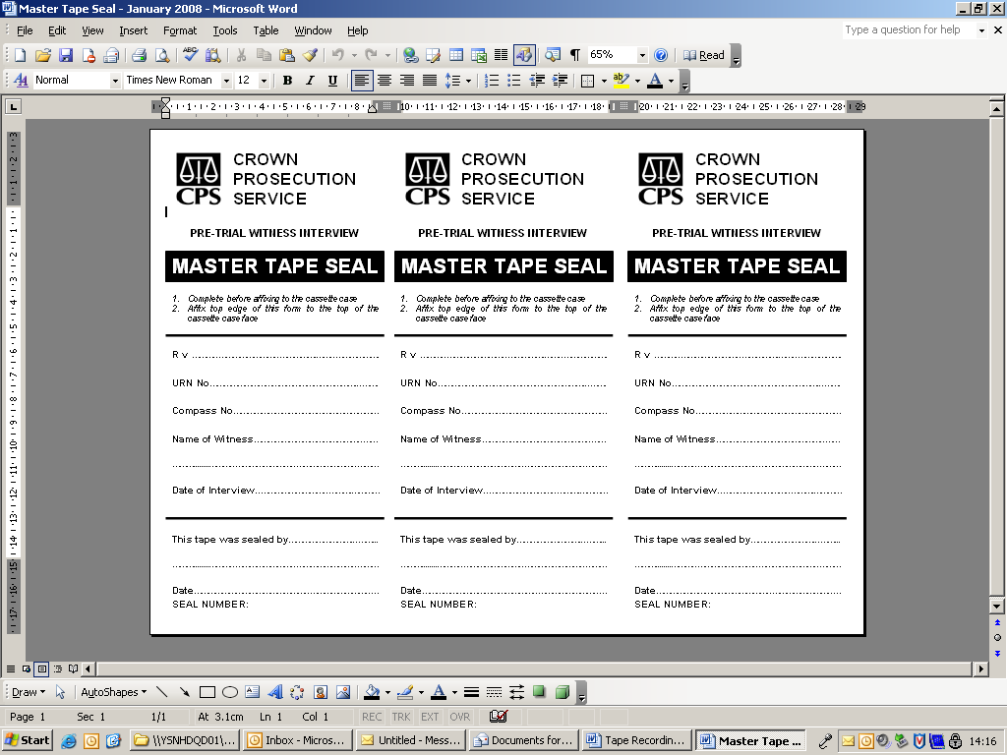

3.7 The master copy must be retained in a secure cabinet and an entry made in the master tape control log recording the following information:

Date, Tape Number, Compass Number, Defendant, Witness Name, Date of Interview, Signature Out / In

3.8 In the unlikely event that a prosecutor wishes to open the master tape before the trial [possibly in circumstances where the working copy has been mislaid and further copies of the tapes are required] the approval of the District Crown Prosecutor / Unit Head must be obtained. An appropriate entry must also be made in the master tape control log.

4 Changing Tapes

4.1 When the recorder shows the tapes have only a short recording time left, the interviewer will advise the witness that the tapes are coming to an end and round off that part of the interview. The prosecutor will remove the tapes from the tape recorder and insert new tapes which will be unwrapped and opened in the presence of the witness. The recorder will then be set to record using the new tapes.

4.2 To avoid confusion between the tapes, the interviewer will mark the tapes with an identification number immediately they are removed from the tape recorder.

5 Taking a break during the interview

5.1 There is nothing to prevent either the prosecutor or the witness from taking a break during the interview but the integrity of the tapes must be preserved. The fact that a break has been taken should be recorded on the tape.

5.2 When a break is taken and the interview room vacated by the witness, the tapes will be removed from the tape recorder and the procedures for the conclusion of the interview followed. Please refer to paragraphs 3.6 and 3.7.

5.3 Where a break is a short one and the witness remains in the room, the tape recorder may be switched off. There is no need to remove the tapes.

6 Failure of the recording equipment and / or tapes

6.1 If there is an equipment failure which can be rectified quickly, for example, by inserting new tapes, the prosecutor will follow the procedures at paragraph 4.1 above. When the recording resumes, the prosecutor will explain what happened and record the time the interview recommences.

